Lab Assignment - 3

**MODULATION USING SIMULINK**

1. Build the Simulink model of AM modulator with parameters Carrier Signal frequency = 2*pi*25, Message Signal frequency = 2*pi and sampling time=1/5000. Amplitudes of both signals are 1

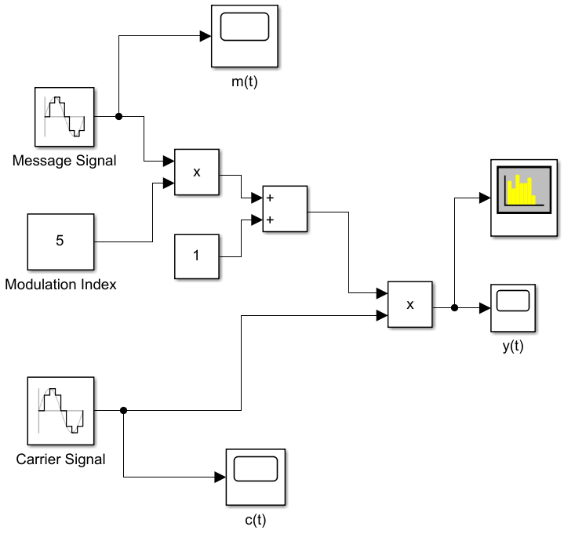

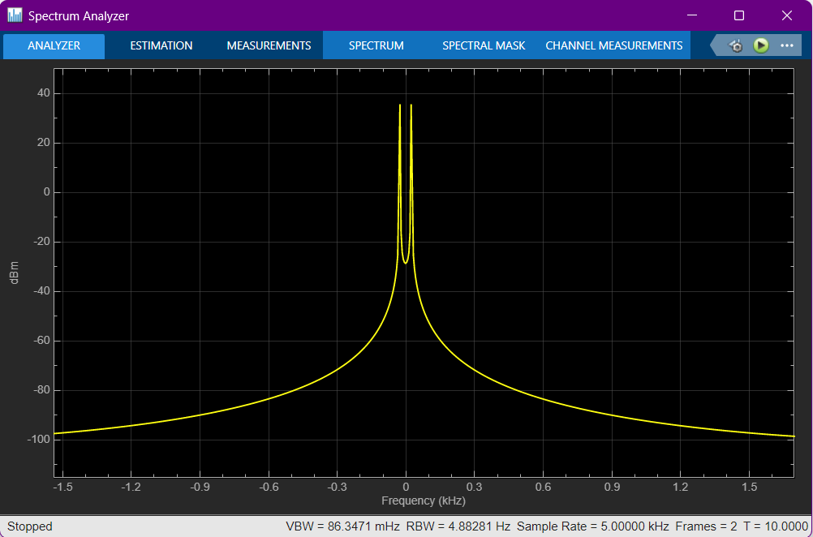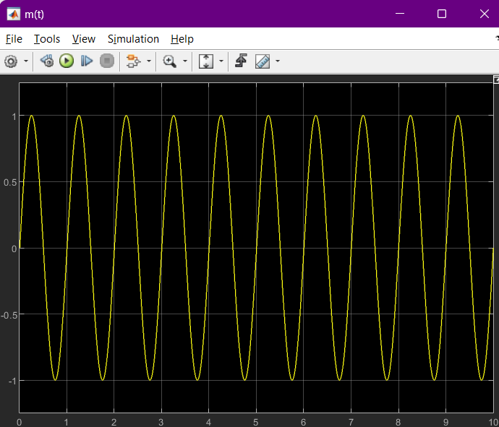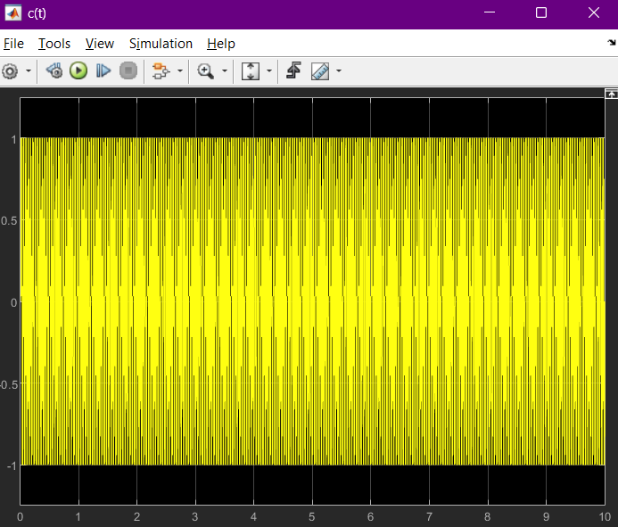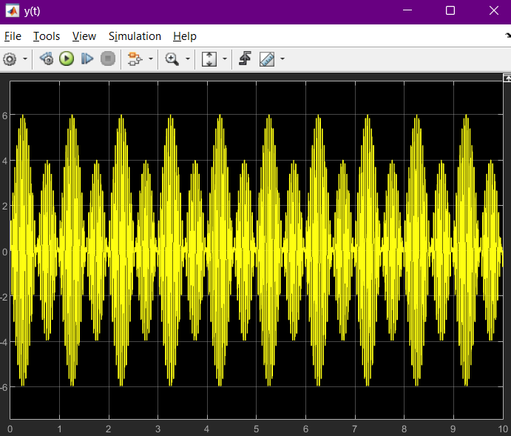

1. Build the Simulink model of FM modulator.

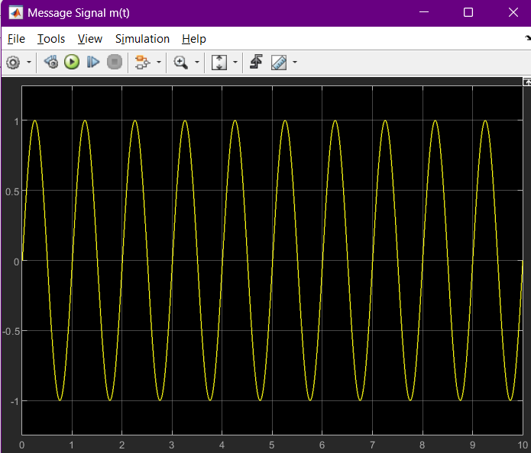 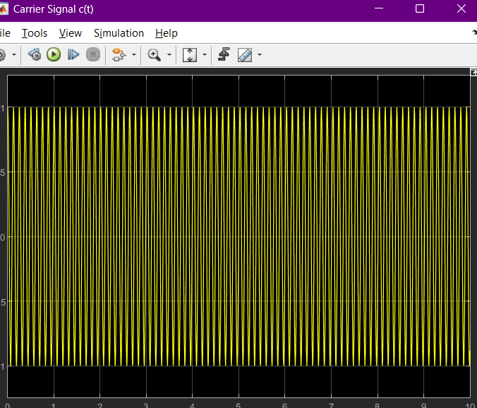

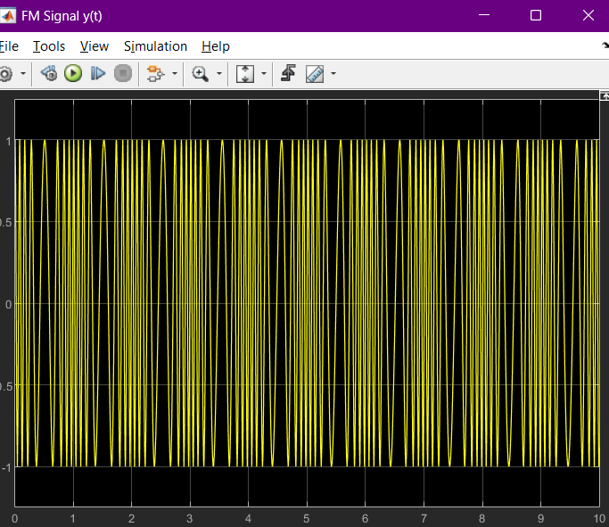  
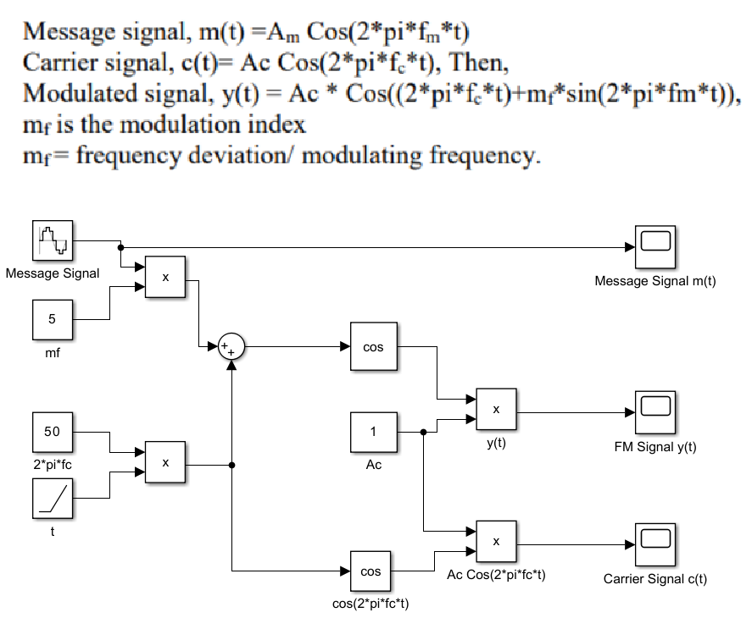

1. Build Simulink Model of 16 QAM Modulator and Demodulator.

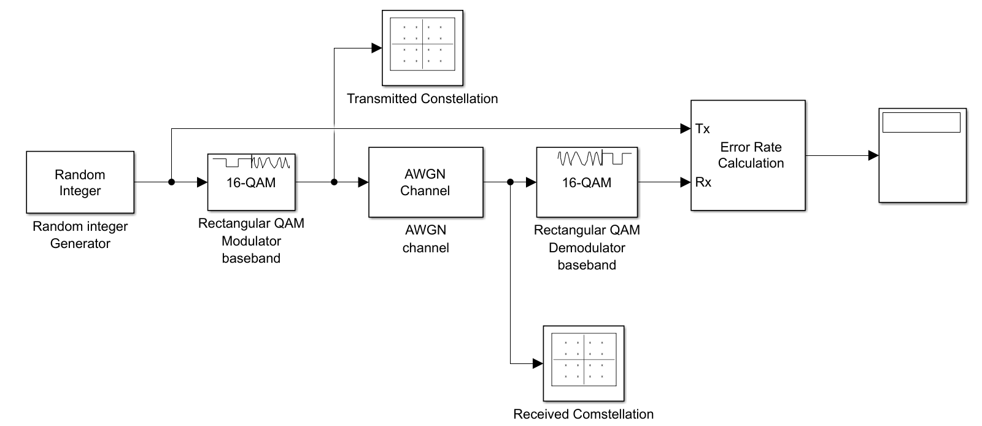

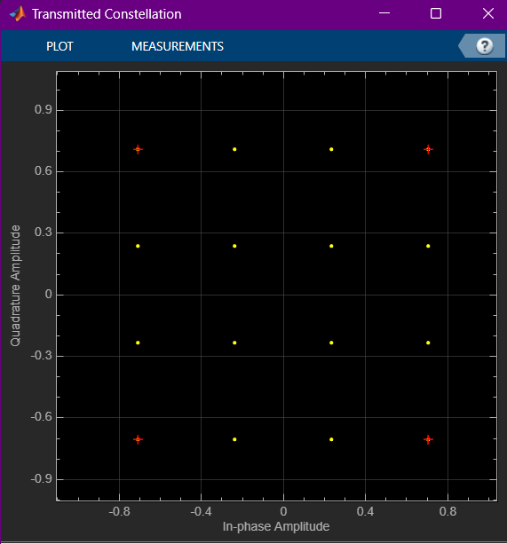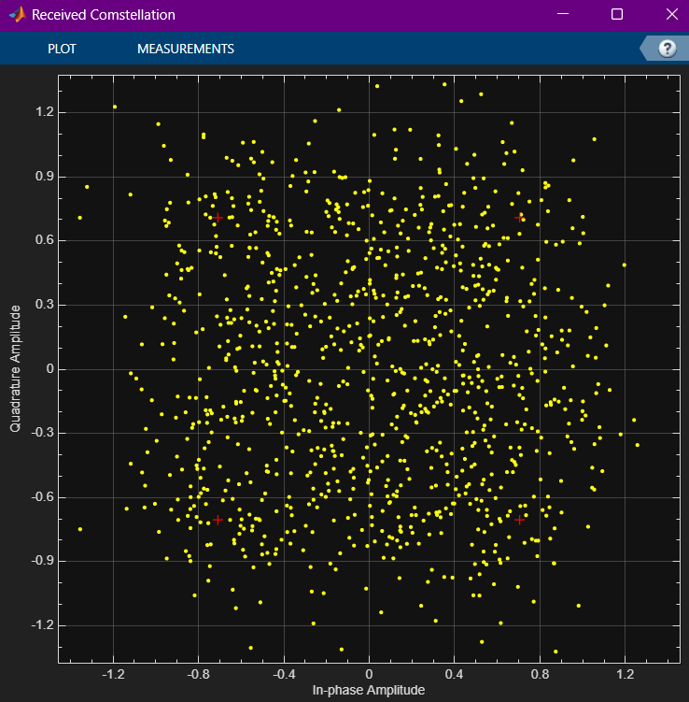

1. Try to simulate a music file transmission using 16 QAM modulation with AWGN channel (model is given below).

